Ford Focus (1999 – 2007) – fuse box diagram (EU version)
Year of production: 1999, 2000, 2001, 2002, 2003, 2004, 2005, 2006, 2007

Passenger junction box.
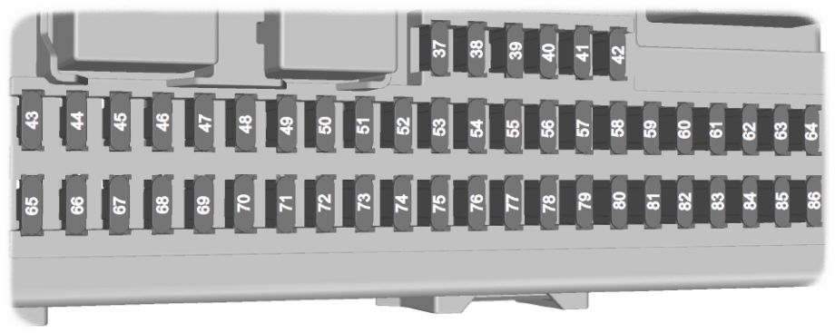
Fuse | Ampere rating (A) | Circuits protected
37 | 10 | Main beam left-hand side
38 | 10 | Main beam right-hand side
39 | 20 | Cigar lighter, rear auxiliary power socket
40 | 20 | Electric sunroof control module
41 | 20 | Front passenger door module
42 | 7,5 | Heated exterior mirrors
43 | 10 | Heater control, steering column, DPF, remote control receiver, DVD player, alarm
44 | 10 | Not used
45 | 10 | Daytime running lamps (parking lamps)
46 | 10 | Instrument cluster battery supply, on-board diagnostics ***
47 | 15 | Washer pump, heated washer jets
48 | 20 | Daytime running lamps
49 | 15 | Lighting control battery supply ***
50 | 20 | Windscreen wipers
51 | 15 | Fuel pump
52 | 25 | Heated rear window
53 | 7,5 | Parking lamps, side lamps, tail lamps (left-hand side)
54 | 7,5 | Parking lamps, side lamps, tail lamps (right-hand side)
55 | 20 | Central locking, driver door module
56 | 20 | Key free system
57 | 10 | Battery backup sounder
58 | 15 | Audio modules battery supply
59 | 20 | Trailer tow module, luggage compartment auxiliary power socket
60 | 15 | Dipped beam, right-hand side
61 | 15 | Dipped beam, left-hand side
62 | 20 | Driver’s electric seat
63 | 25 | Electric windows
64 | 20 | Not used
65 | 10 | Airbag module
66 | 7,5 | Lighting control ignition supply
67 | 10 | Instrument cluster ignition supply, engine immobiliser
68 | 7,5 | Accessory to cluster (audio and navigation unit)
69 | 20 | Fog lamps
70 | 10 | Electronic modules ignition supply
71 | 10 | Daytime running lamps ignition supply to lighting control switch
72 | 25 | Not used
73 | 7,5 | Number plate lamps
74 | 15 | Brake lamps
75 | 10 | Powertrain control module, accelerator pedal, automatic transmission
76 | 7,5 | Electric parking brake
77 | 25 | Central locking relays
78 | 15 | Rear window wiper
79 | 15 | Electric folding mirror
80 | 10 | Battery saver, interior lamps
81 | 20 | Door module, right-hand rear
82 | 20 | Door module, left-hand rear
83 | 10 | Audio modules (high level)
84 | 10 | Reversing lamp, electric mirrors
85 | 10 | Cooling unit
86 | 20 | Heated front seats

Engine junction box.
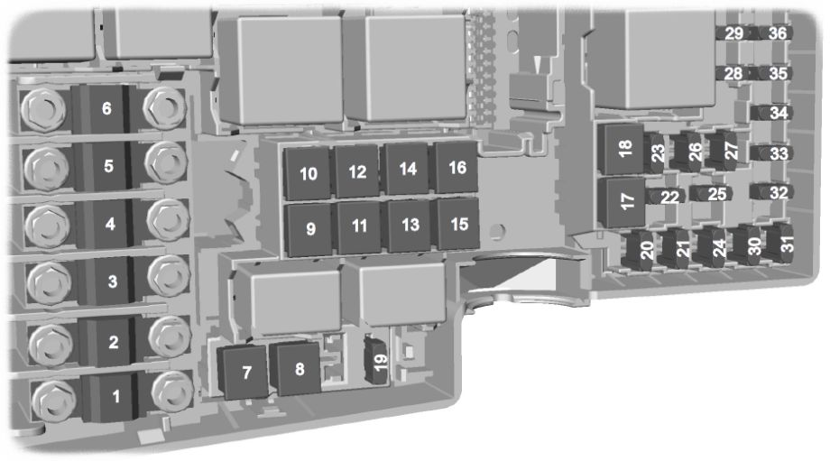

Fuse | Ampere rating (A) | Circuits protected
1 | 50 | Cooling fan
2 | 80 | Power steering
3 | 60 | Passenger junction box supply 1
4 | 60 | Passenger junction box supply 2
5 | 80 | Climate control
6 | 60 | Auxiliary heater (diesel only)
7 | 30 | Dodatkowa nagrzewnica (disel only)
8 | 20 | ABS, stability control pump
9 | 20 | Powertrain control module (all except FocusST)
9 | 30 | Powertrain control module (FocusST only)
10 | 30 | Climate control blower
11 | 20 | Ignition switch
12 | 40 | Ignition relay 15l
13 | 20 | Starter solenoid
14 | 40 | Heated windscreen, right-hand side
15 | 30 | Cooling fan relay
16 | 40 | Heated windscreen, left-hand side
17 | 30 | Electric parking brake (all except convertible)
17 | 30 | Roof control module (convertible only)
18 | — | Not used
19 | 10 | ABS module
20 | 15 | Horn
21 | 20 | Auxiliary heater
22 | 10 | Power steering module
23 | 30 | Headlamp washer
24 | 15 | Auxiliary heater (diesel only)
25 | 10 | Ignition, relays
26 | 10 | Automatic transmission
27 | 10 | Air conditioning clutch
28 | 10 | Glow plug monitoring (diesel only)
29 | 10 | Dual zone climate control
30 | 10 | Powertrain control module, automatic transmission
31 | 10 | Battery sensor smart charging ***
32 | 10 | Automatic transmission
32 | 10 | Fuel injector power supply (FocusST only)
33 | 10 | Heated oxygen sensors (petrol only)
33 | 10 | Intercooler bypass valve (diesel only)
33 | 20 | Heated oxygen sensor (FocusST only)
34 | 10 | njectors, ignition transformers
35 | 10 | Powertrain control module, valves, solenoids (all except Focus ST)
35 | 15 | Powertrain control module, valves, solenoids, crank heater element (FocusST only)
36 | 10 | Powertrain control module

